Hebrew rhythm class: A study of rhythm class across languages

Jennifer Markovits Rojas

**Rutgers University**

ABSTRACT

The present study aims to investigate a previous language that has not been categorized into rhythm categories: Hebrew, examining whether Hebrew falls in stress-based rhythm continuum, making a comparison between English L1 L2 Hebrew with Hebrew natives and English L1 L2 Spanish with Spanish natives. The current work also examines whether proficiency affects rhythm patterns in languages between or within the same rhythmic category

Keywords: rhythm class- Hebrew- Spanish- L2 acquisition.

# INTRODUCTION

Rhythm is the sense of movement in speech, marked by the stress, timing, and quantity of syllables (Cumming, 2010). Within the previous definition, some languages are well-known classified as syllable-timed, like Spanish and stressed-timed, like English. However, several languages do not have a definite rhythm classification, for example, Hebrew. Therefore the present study examines vowel duration from L1 English who are learning an L2 language with no precise rhythm class classification –Hebrew- and L1 English who are learning a well-known syllable time language, Spanish, that differ from English, stress-timed. This project will first review the literature in rhythm class and L2 rhythm acquisition to understand which features are relevant in measuring rhythm patterns in a language. Then data from L1 and L2 of the target languages will be segmented to reveal vowel duration in Spanish and Hebrew. Looking at the differences between L2 learners with different L1 rhythm patterns compared to the target languages will display whether Hebrew share prosodic features with English. Also, the data will provide evidence about the effect of proficiency in vowel duration in L2 acquisition.

# Theoretical background

Rhythm class is a prosodic feature of the speech, and it is defined as the up and downbeat of the strong and weak units of a given language (Aldrich, 2019). The idea of cross-linguistic rhythmic variation was first documented by Arthur Lloyd James (1940). The author defined the rhythm pattern as a combination of duration, lexical stress, and melodic contour. He distinguished between two types of beat patterns: a Morse-code, that classifies English-like rhythm languages and machine gun, that described French-like rhythm languages. Later, Pike (1947) elaborated on the idea of categorical rhythm classes. He postulated the notion of isochrony that is the rhythmic division of time into equal portions by a language. Based on the previous concept languages could be classified in three classes: a)stress-timed, language whose stress- syllable were equal unlike the unstressed syllables (English), b) syllable-timed: languages whose syllable were equal (Spanish) and mora- timed, languages whose mora were equal (Japanese).

However, empirical studies on rhythm unit duration had rejected the notion of isochrony. Aldrich and Simonet, (2019), examined Spanish vowel duration by syllable structure and the findings supported the hypothesis that syllable structure modulated acoustic vowel duration. This suggested that syllables did not have an equal duration in a syllable-timed language. Nevertheless, there must be other factors to measure syllable duration, and, on the other hand, the categorical idea of language rhythm could be better seen as a continuum rather than purely categorical. Grabe and Low (2002) provided evidence for rhythmic classifications of speech, providing different duration measurements. The authors calculated the durational variability on acoustic-phonetic intervals using Pairwise Variability Indices. The results showed that stress-timed languages (French and Spanish) displayed a more significant duration variability than syllable-timed languages (English and German). Besides, the authors concluded that language rhythm is gradient since previously languages that had not been categorized into rhythm categories seemed to overlap between the two.

In sum, the previous studies demonstrated that some groups of languages share a beat pattern that is related to segmentation duration. Furthermore, evidence shows that languages can overlap between the two categories. Therefore, the present study attempts to examine whether Hebrew share more similarities in vowel duration with English, a stressed timed language or Spanish, a syllable-timed language, or, whether the language overlap between the two classifications.

## L2 rhythm and linguistic experience

Rhythmic patterns change as proficiency increases even when the native and the learners' target languages are rhythmically similar (Ordin, Polyanskaya, and Ulbrich, 2011). The authors investigated the development of speech rhythm in second language acquisition in L2 learners of English with different L1 rhythm speech (French and German). The results showed that both groups showed similar development of speech rhythm in L2 acquisition as L2 acquisition progressed; however, there were also differences. German L2 English achieved a durational variability target-like, and French L2 English exhibited a lower variability than English natives even at advanced proficiency levels. Regarding Spanish and English, Aldrich (2019) investigated whether linguistic experience affected the consonantal and vowel duration production in L1 English-L2 Spanish. The author founded that L2 speakers made gains in their speech rate in Spanish with increasing linguistic experience, suggesting that these results were evidence of the development of L2 rhythm. Therefore, the present study examines whether proficiency has similar effects in L2 regardless of L1 rhythm language typology.

# The present study

The present study attempts to demonstrate phonetic similarities between Hebrew and English comparing vowel duration between Hebrew natives and L1 English L2 Hebrew learners; and Spanish natives and L1 English L2 Spanish learners. The current work follows previous studies (Becker, 2003) that suggested that Hebrew should be understood as a realization of metrical structure, namely trochaic feet, and trochaic feet is related to stress-timed languages (Niebuhr, 2012). Also, the present work examines whether proficiency is a good predictor of vowel duration variability between L2 learners with different L1 rhythm typologies following studies that support the hypothesis that experience shifts rhythm production (Aldric, 2019), but there are differences of target-like production based on L1 rhythm class (Ordin et al., 2011).

## 3.1 Participants

The sample pool included 128 participants: 32 L1 English-L2 Spanish learners, 32 L1 English- L2 Hebrew learners, 32 Spanish-dominant Spanish-English bilinguals, and 32 Hebrew-dominant Hebrew-English bilinguals.

## 3.2 Materials and procedure

The selection of the material included six items from MINT (Gollan, Weissberger, Runnqvist, Montoya, and Cera, 2012) for each language produced by the participants. MINT is a Multi-Lingual Naming Test. The test measured spoken language dominance. It contained 68 pictures. Participants saw a picture, and they named it at their own pace. The selection included six disyllabic items in Spanish and Hebrew. The first syllable had no coda, and the second syllable had no coda for the Spanish items, and four of six words had coda for the Hebrew items.

The segmentation of the acoustic data was made in Praat. Each token was segmented in three tiers: word duration, vowel1 duration, and vowel2 duration. The fourth segmentation was a point tear that indicated language (Hebrew-Spanish) and type of language (L1 or L2).

Figure 1: segmentation in Praat

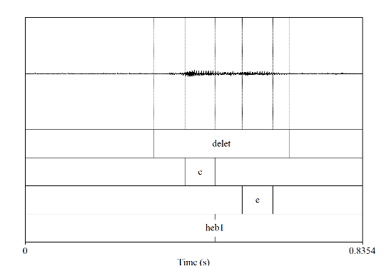

# Results

# Vowel duration and type of language

Four linear models were run to examine whether type of language (Hebrew-Spanish) had an effect in vowel duration. The first model examined the effects of vowel 1 by Hebrew language and it showed no significant effect (β = 0.002, SE = 0.003, z = 0.074, p = 0.439) unlike the second model that showed a significant effect in vowel1 duration by Spanish (β = 0.01, SE = 0.003, z = 5.243 p < 0.01 )

Model 3 examined the effect of Hebrew in vowel2 duration. Like the first model, no interactions were found (β = 0.00, SE = 0.004, z = 1.907, p = 0.057 ) unlike model 4 that did found interactions between vowel2 duration and the Spanish group (β = 0.03, SE = 0.004, z = 7.65 p < 0.01 )

Figure 2: Vowel1 duration median by language

**Figure 3:** vowel2 duration median by language

## 4.2 Vowel duration and proficiency

Two models were run to examine whether L2 learner’s proficiency had an effect in vowel1 duration. For vowel1 duration the models founded no significant effects neither for Hebrew (β = -9.89 SE = 2.14, z = -0.46, p = 0.06) nor Spanish (β = -0.00 SE = 0.00, z = -1.85, p = 0.06)

**Figure 4:** vowel1 duration by proficiency (MINT)

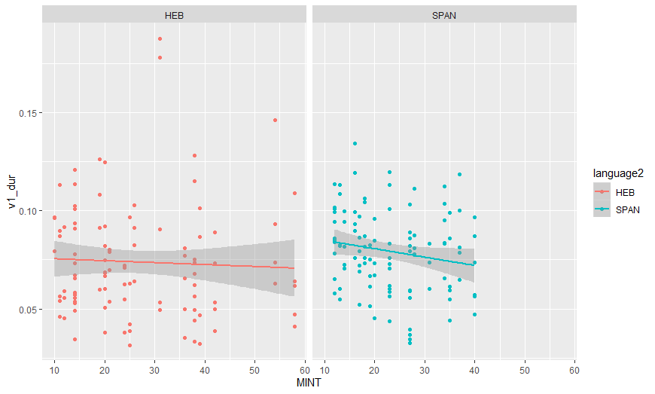

## Two models were run to examine whether proficiency had an effect in vowel2 duration. The model showed significant effects for the Hebrew L2 group (β = -0.00 SE = 0.00, z = -2.81, p > 0.01). On the other hand, the model did not find a meaningful interaction between vowel2 and Spanish L2 learners (β = -0.00 SE = 0.00, z = -0.76, p = 0.44)

# Discussion

## Hypothesis 1 states that Hebrew shares vowel duration similarities of stress-timed language. The results supported the hypothesis showing that L1 English L2 Hebrew produced lower variability in vowel duration compared with native Hebrew than L1 English L2 Spanish compared with native Spanish. The previous results are in line with Becker (2003), who claimed that Hebrew has a trochaic metrical structure and, on the other hand, Niebuhr (2012) stated that stress-timed languages have a rhythm pattern closer to a trochaic foot. Hypothesis 2 stated that proficiency affects vowel duration. The results were not supported by vowel 1 results and were partially supported by vowel 2 results, showing that MINT scores shifted vowel duration in L1-English L2 Hebrew. Previous studies do not support the results of the two model for vowel 1 and one model for vowel 2 by L2 Spanish learner’s MINT scores since several studies suggested that linguistic experience influenced outcomes in second language speech (Tortel and Hirst, 2010; Ordin et al., 2011; Aldrich, 2019). Therefore, it is possible to conclude that the measure used in the present work is not accurate to test the relation between suprasegmental features and proficiency in second language acquisition.

# Conclusions

The principal finding of this study was that Hebrew shares more prosodic features with English than Spanish, suggesting that Hebrew falls in the stress-timed continuum rather than the syllable-timed continuum. On the other hand, the present work attempted to examine the relationship between vowel duration in L2 learners and proficiency, but the measure selected in the current investigation is not an accurate factor to examine the development of L2 rhythm.

# REFERENCES

1. Aldrich, A. C. (2019). Gestural Development in Adult Second Language Acquisition: Targets and Timing.
2. Arvaniti, A., & Ross, T. (2012). Rhythm classes and speech perception. Understanding prosody: The role of context, function, and communication, 13, 75.
3. Becker, M. (2003). Hebrew Stress: Can't you hear those trochees?. University of Pennsylvania Working Papers in Linguistics, 9(1), 5.
4. Carter, P. M., & Wolford, T. (2016). Cross-generational prosodic convergence in South Texas Spanish. Spanish in Context, 13(1), 29-52.
5. Coetzee, A. W. (1996). The neutral reduced vowel, vowel epenthesis, and segholate formation in tiberian hebrew. South African Journal of Linguistics, 14(sup31), 5-21.
6. Cohen-Gross, D. (2015). The syllable structure in the Modern Hebrew noun and adjective system. Hebrew Studies, 175-190.
7. Cumming, R. E. (2010). *The language-specific integration of pitch and duration* (Doctoral dissertation, PhD thesis. University of Cambridge).
8. James, A. L. (1940). Speech signals in telephony. Sir I. Pitman & sons, Limited.
9. Laufer, A. The origin of the IPA schwa.
10. Niebuhr, O. (Ed.). (2012). Understanding prosody: The role of context, function and communication (Vol. 13). Walter de Gruyter.
11. Pike, K. L. (1947). The Intonation of American English. Ann Arbor: University of Michigan Press.
12. Segal, O., Nir-Sagiv, B., Kishon-Rabin, L., & Ravid, D. (2009). Prosodic patterns in Hebrew child-directed speech. Journal of Child Language, 36(3), 629-656.
13. Tortel, A., & Hirst, D. (2010). Rhythm metrics and the production of English L1/L2. In Speech Prosody 2010-Fifth International Conference.